**Skoovy Android App**

Hot Salsa Interactive LLC

Cole, Tyler; Kowal, Anthony; Matthews, Lilith; Wever, Rudi

**First Demo or Prototype | Screenshots**



Figure1. This is the start view. Here the user chooses to login or sign up.

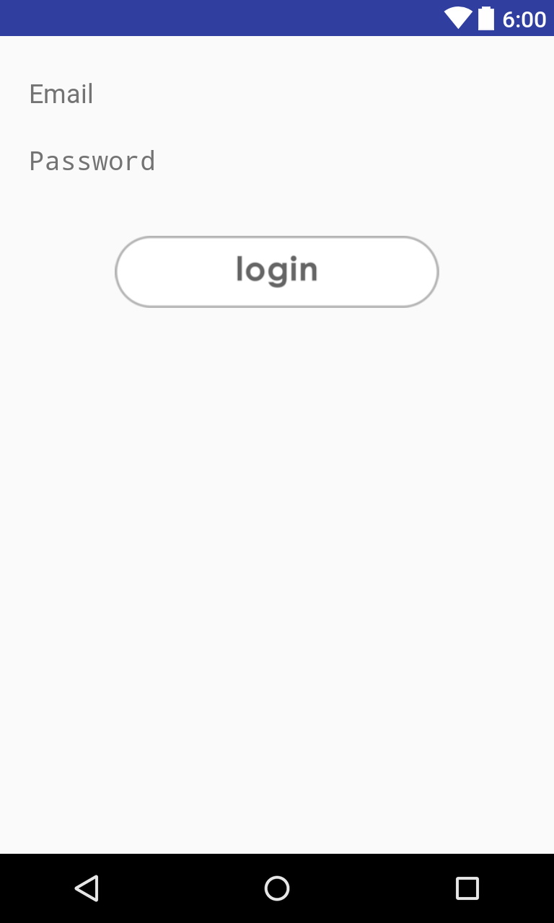

Figure 2. The user chooses to sign in with email and password.

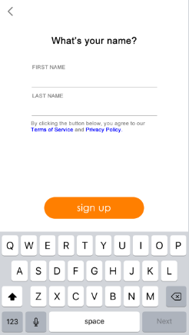

Figure 3. The user Inputs their First Name and Last name and then continues with sign up button. User may select back at any time with the top left button.

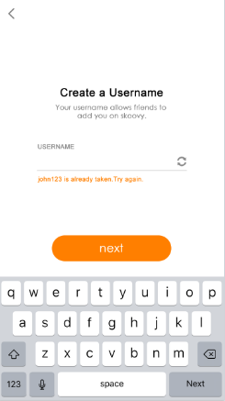

Figure 4. The user makes a user name. Then selects next o continue. User may select back at any time with the top left button.

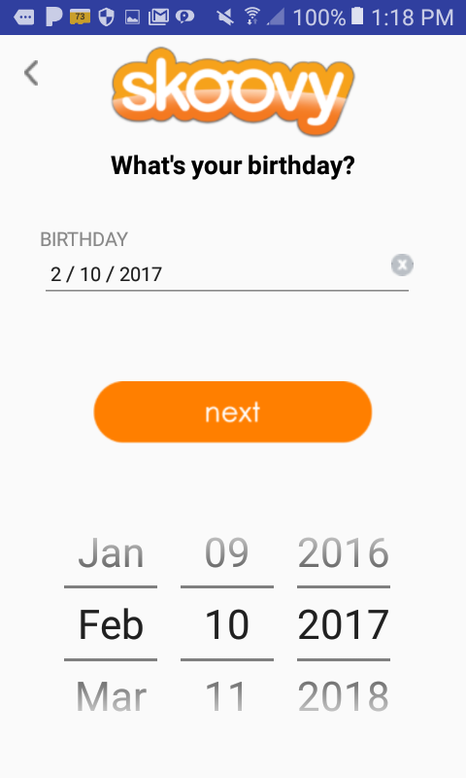

Figure 5. The user inputs their birth date with the rotary picker. User then moves on selecting the next button. User may select back at any time with the top left button.

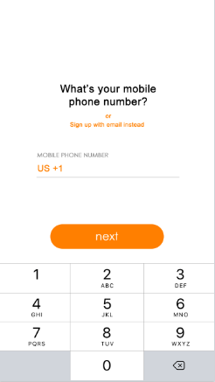

Figure 6. The user inputs their phone number. If they select to use their email instead they will be moved to Figure 7. User will select next if chose this input of phone number. User may select back at any time with the top left button.

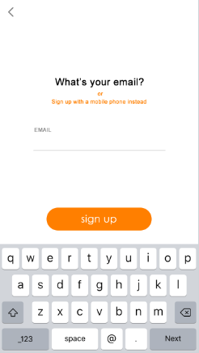

Figure 7. The user inputs their email. If they select to use their phone number instead they will be moved to Figure 6. User will select next if chose this input of email. User may select back at any time with the top left button.

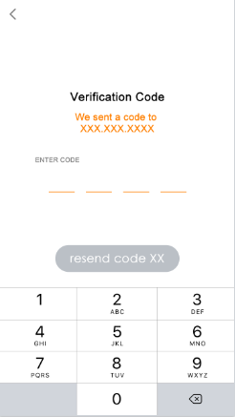

Figure 8. The user inputs their Verification Code. User will select resend code if they did not receive the code. User may select back at any time with the top left button.